# Chapter 1: Introduction, Statement of Problem

The Port of Virginia is the 5th largest in the US, 3rd largest on East Coast. 2nd Largest single operator in the US. In 2008 APM-T went live with a rail mounted gantry crane terminal in Portsmouth. Virginia Port Authority took over running it in 2010. That facility had 30 Rail Mounted Auto Stacking Cranes (ASC) in fifteen stacks. These cranes are now 12 years into their expected 22 year life span, and are starting to see wear.

The operational model pioneered by the facility, now called Virginia International Gateway (VIG) was so successful that the port replicated the system at Norfolk International Terminal (NIT) adding an addition 60 ASCs in 30 stacks. Also, VIG was expanded with an additional 13 stacks with 26 ASCs. At the time the expansion was announced, the 86 ASCs ordered for VIG and NIT was the largest single order for cranes in the port industry history. These two projects represented investments of $460m and $320m respectively. The last NIT new ASC came online in December of 2020.

Now in full operation, and with 10 months of data, the fleet of 86 new and 30 original ASCs will cost the port over $17.5m in maintenance expenses. There is additional costs to team operating the terminal that can be significant. While a ship is working, roughly 3 stacks are supporting each crane, and the containers are needed in a specific order. If an ASC were to break during the operation, a the Quay crane with 26 workers has to have to wait for a repair. This costs in order of $2,500 an hour during the day, and $3,750 an hour nights and weekends.

# Chapter 2: Literature Review

## Elastadynamic Finite Integration Technique

Initially proposed in Fellinger in his dissertation in 1991. He was a student at the University of Kassel, Department of Electrical Engineering/Computer Science. His work was then extended by . Used for several dissertations in the lab

Started with Jill Bingham’s dissertation 2008

·         Read Fellinger 1995

o   Still awaiting library to find Fellinger’s Phd from 1991

·         Read Marklien’s 2002 chapter on EFIT, AFIT and EM FIT.

·         Read Madariaga’s 1976 paper on Finite Difference Time Domain elastic equations in 2d circular, it is credited by Marklien for introducing staggered grid to elastic dynamics

## Rail Structural Health Monitoring

Large problem using ultra sound. Needed a whole train car full of racks for computers

Found an article that summarize the current state of ultrasonics in rail heal monitoring, published earlier this year (Bombarda 2021). The paper is focused on Ultrasonic methods and does not include the Eddy Current methods.

Next I am reading one of his cites, a state of the field written in 2014 (Rizzo 2014).

## Ultrasonic Examination in Non-Destructive Evaluation

Raleigh waves, crack detection lamb waves in plates

Started with Rose 2002

·         Found Felice 2018 a review of 2000-2018.

·         Also found and read Doyle 1978 an earlier review of 1960s and 1970s research on ultrasonics

## Evolution of Available Sensors and Edge Computing techniques

Sensor technology with MEMs accelerometers and gyroscopes in the late 90s Edge computing and fog through the early 2000s

# Chapter 3: Methods

## Proposed Data Collection

Preliminary data collection has been begun with a 3 axis acceleration sensor and 3 axis gyroscope connected to a Raspberry Pi. The system is zip tied on a tray in the equipment house on an ASC. This sensor is then left in position for several days collecting movement data. Every few days the sensor needs to be physically removed, have the stored data copied off, and then installed on another crane. This has been collecting data since July 11, 2021. The current system uses python to to read the acceleration as often as the loop runs, and save the data off after 60,000 reads. The files for Acceleration and Gyrscopic Acceleration are saved and zipped for size storage. Collecting 60,000 rows represents about 9 to 10 minutes of data. A time stamp from beginning of the loop is stored with each record, and the file name is stored as the end time of file.

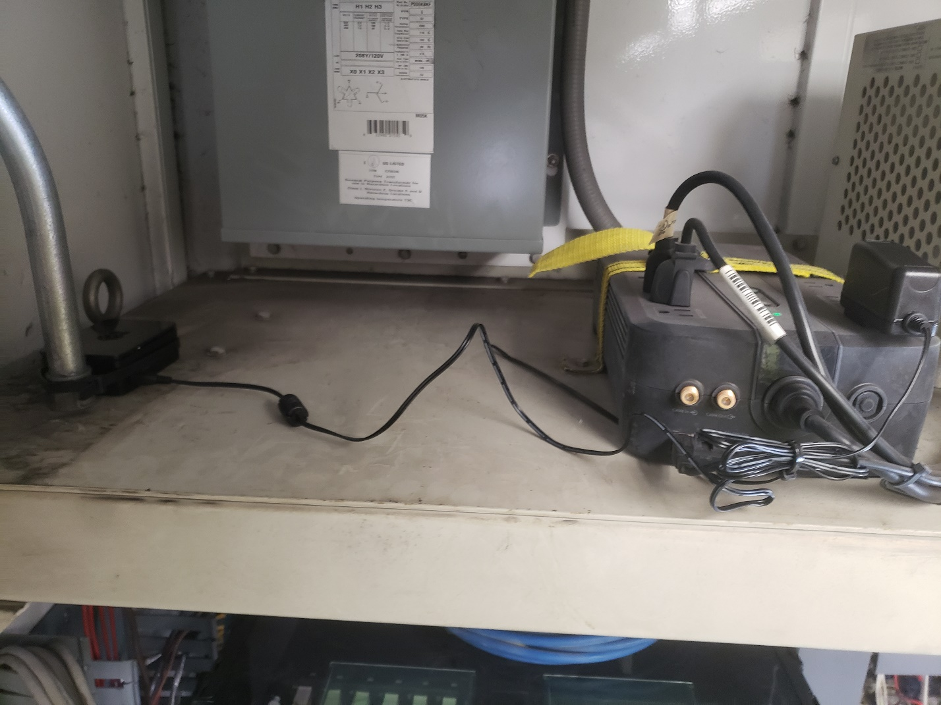

In the future there is potential to permanently mount a computer in the equipment house connected to acceleration sensors installed closer to the wheels and tracks. The crane has 10GBs fibre connection to the port’s network that can be used to collect data, instead of the manual method currently. The total generated would be too large for the network as a whole, even though a small percentage of each link. Data could be stored on the crane for a rolling 14 days, and data only pulled remotely when there has been an event that is to be studied.

Additional vibration, ultrasound, or acceleration sensors as discussed above could be placed directly on the rails. The end of the rail is exposed and above ground. Potentially sensors can be mounted on the surface, the web, the end, and bottom of the rail looking for different signals. Further analysis can be conducted with standard ultrasound equipment such as a rail analysis walking stick discussed above.

## Data Preparation

Manually label acceleration curves for a number of the les. Label as Acceleration, Coasting, Decelerating, Idling. Then train a Neural Network to automatically segment each acceleration into the 4 types, properly labeling them. I will then be able to use that network to label all 3 months of data. Next step will be a‑xing any additional metadata that are available to those segmented sections.

## New Analysis Technique

Standard wavelet families are made to analyze a whole signal, and work across portions of a signal. Wavelets are made up of a carrier signal and a changeable signal. The Gaussian wavelets are a commonly used family that work by using a Gaussian or normal distribution as the Carrier signal, and then multiplying it by either a sine or cosine signal. The sine or cosine signal is then scaled at different frequencies. The combined scaled wavelet is correlated with the signal, and the correlation between the signal and the scaling wavelet is stored at each position in time for each scaling factor.

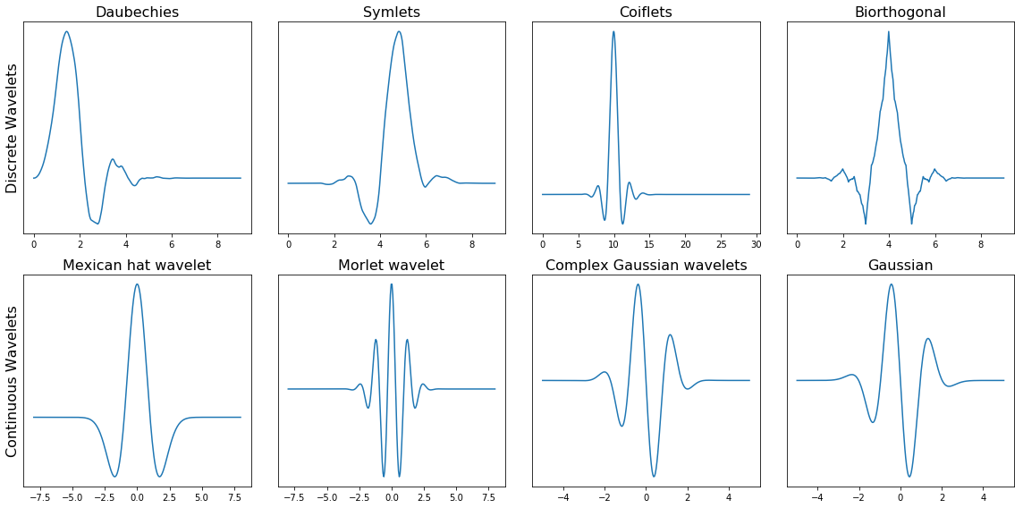

Figure : Wavelets are made up of different families of functions that have similar form, and changing parameters. Families are generally designed such that subsequent members of the family are orthogonal to each other, allowing a complete decomposition of a signal if they are all used.

Through the research different wavelet families will be experimented with, and the optimum for the analysis will be used. A wavelet that shows promise for live signal processing is the beta wavelet. It uses the Beta Distribution as its carrier signal, which has two parameters that can be modified by study, and a scalable signal. The Beta Wavelet has been shown to be useful in real time signal processing for ECGs.

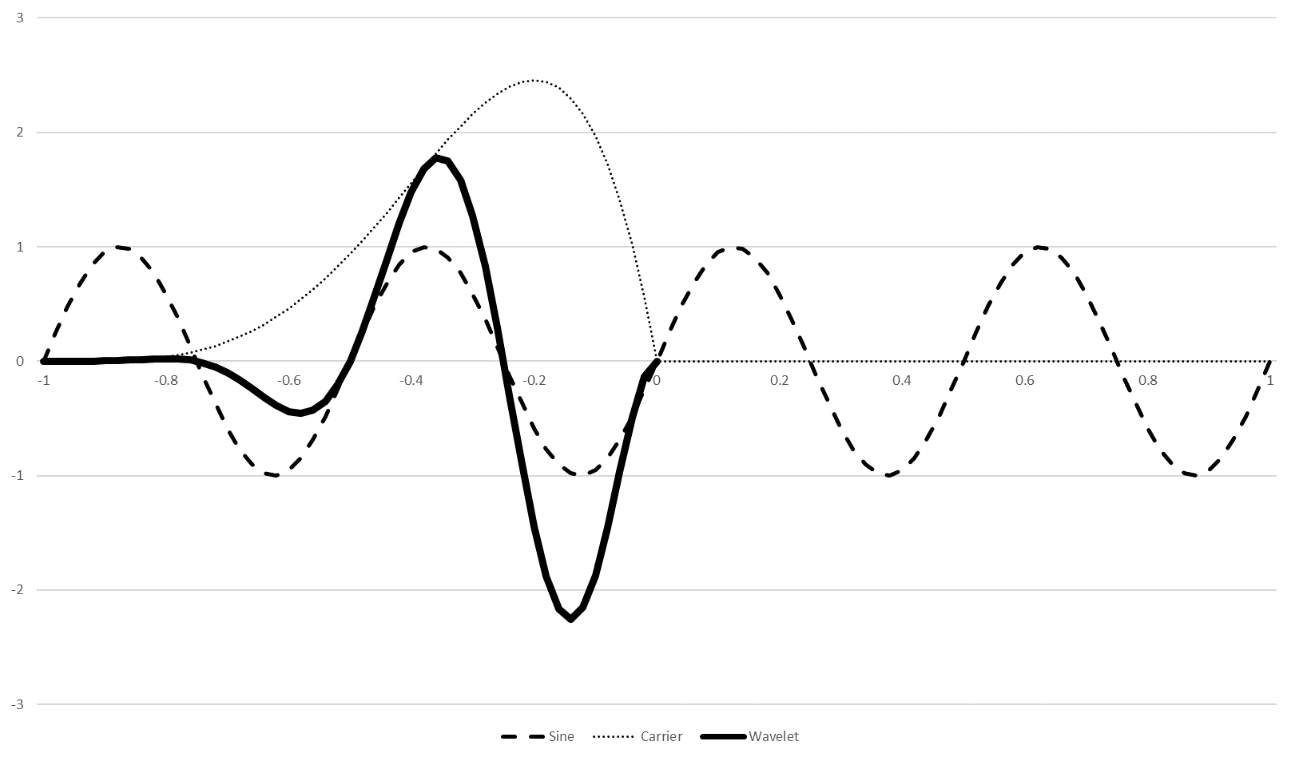

Wavelet based on single directional distribution. Will allow analysis of near recent history. Current wavelet needs to analyze a whole signal, this will allow the analysis of a live stream of data. The Use of the beta function gives flexibility in changing the two beta parameters to determine which best works with the wavelet for feature selection.

This will then be used in conjunction with the Dynamic Wavelet Fingerprinting technique pioneered by Huo in 2004, with continued research implementing it for diverse problems from structural health monitoring in aircraft stringers, 5G signal analysis, and social media bot detection.

## Comparative Analysis techniques

Pit my new Wavelet against the standard Wavelet based approaches. How does a live signal processing wavelet work against the full signal analysis standard wavelets in DWFP. We will also run the direct signal into Recurrent Neural networks and attempt to train on all of the dimensionality that is encompassed in the raw data. There are several options for the type of RNN to use, either a Long Short Term Memory Model, or other types. A third will compare feature selection out of the live Wavelet Fingerprint, RNNs trained on the resultant features.

# Chapter 4: Approach and Pilot Data

Initially an acceleration sensor was coupled with a Raspberry Pi and placed in the House of an ASC. The sensor has then been moved in between multiple cranes. Over the course of the several months that the sensor has been collecting data, it has been on tracks before and after they were ground for smoothness.

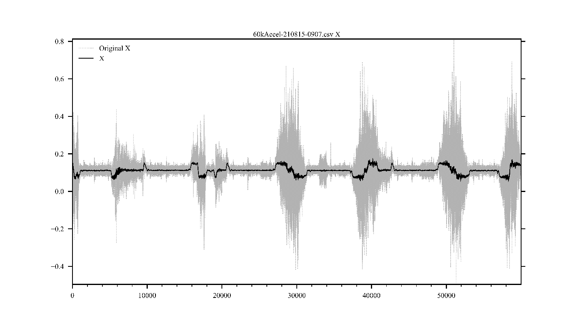

Figure : This shows the original and the smoothed (50 point averaging) acceleration in the dimension roughly parallel to the crane track. The black line is the 50 point average smoothed signal, and the grey dashed line is the raw signal. The periods of acceleration, coasting, deceleration, and idling can be clearly seen in the averaged signal. The amount of noise in the raw signal makes it very hard to detect direction of change of travel, but the smoothing allows for clear visual interpretation for what is happening at each section of movement. The signal is from a series of movements delivering containers to be loaded onto a ship, in a stack where the track was known by the maintenance technicians to be in need of grinding.

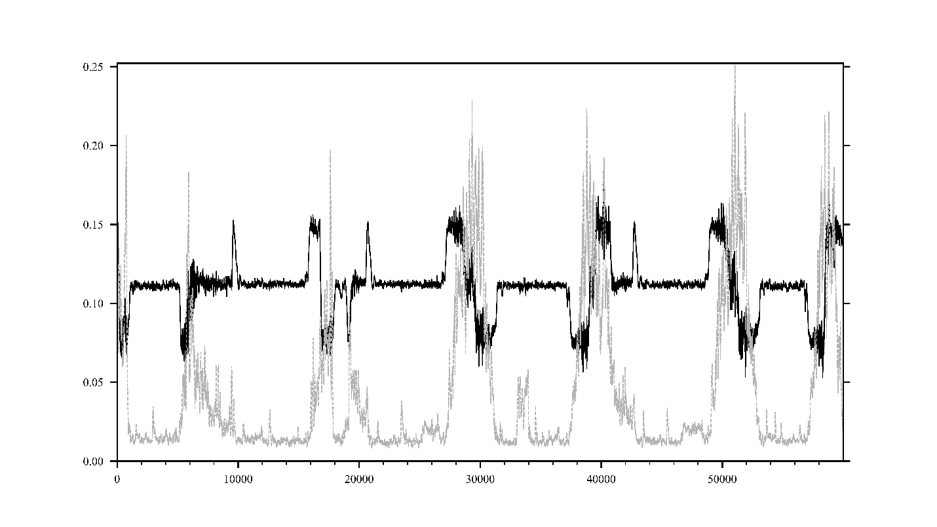

Figure : Showing the same signal as figure 2, with the 50 point average smoothed signal in black, and the standard deviation of the original signal over time in dashed grey. Since the initial goal of the preliminary research and data collection phase is to highlight tracks in need of grinding, the standard deviation of the signal is a good proxy for the roughness of the track. Since all the cranes move at the same velocity, the differences in the standard deviation of the acceleration while they are at constant speed should indicate the roughness of the track that is transferred to the sensor.

Focusing on the area from 24,000 to 36,000 in the graph, there is a period of the crane waiting for its next move, the crane accelerating to full speed, coasting at full speed briefly, decelerating, and then waiting again for its next move. Using this section a Dynamic Wavelet Fingerprint can be created, showing frequency responses. The idle time has no fingerprint structures, while the motion time shows fingerprints that can be analyzed.

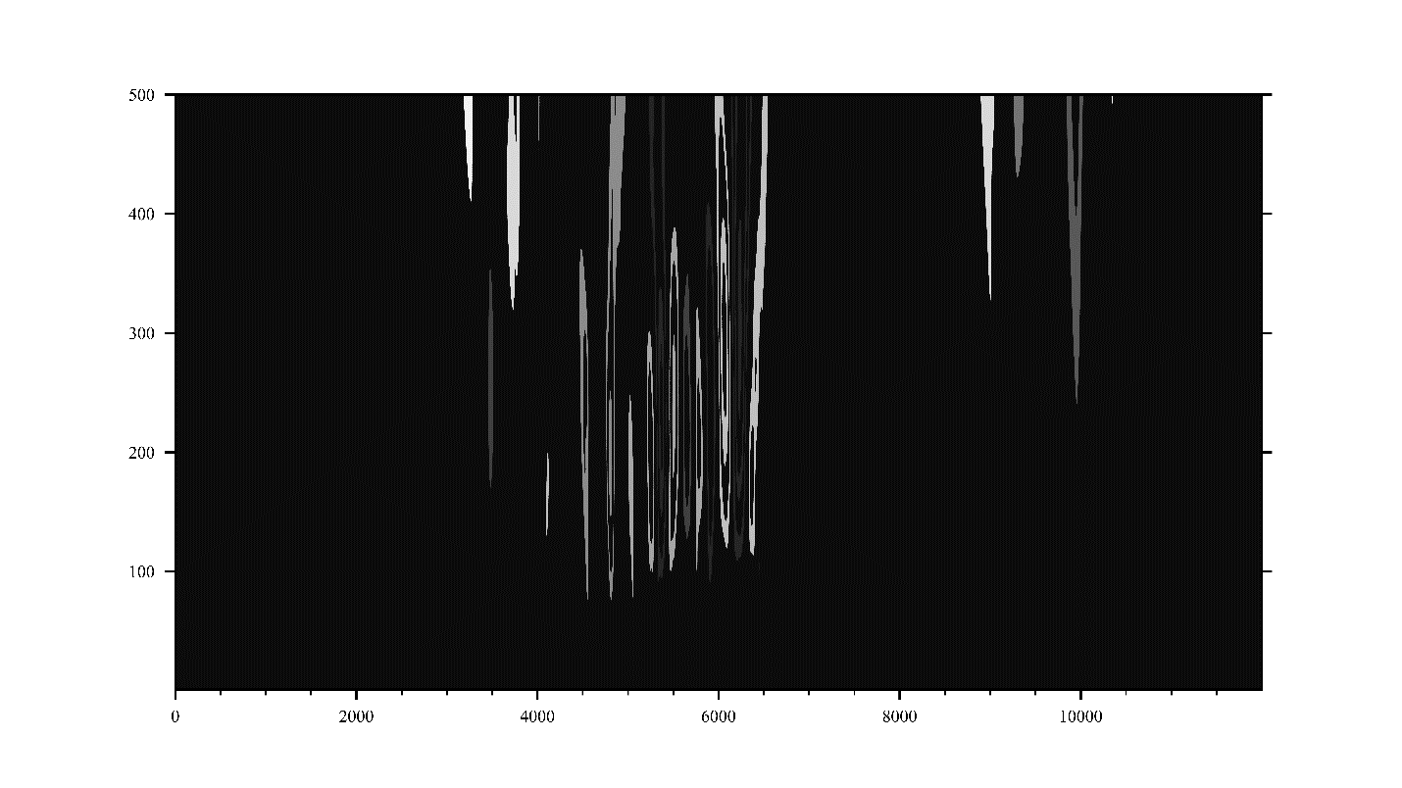

Figure : Dynamic Wavelet Fingerprint of the standard deviation curve of a sample crane move out of Figure 3. The features of the fingerprint can be analyzed, both visually and mathematically, using techniques by Huo, Bingham and others.

## Supporting Information Available

The code used to generate these can be found on the author's GitHub page.

The following files are available free of charge.

GitHub Link: <https://github.com/danchendrickson/Prospectus>

References

(1) Graff, K. Wave Motion in Elastic Solids; Dover Books on Physics Series; Dover Publications, 1991.

(2) Anderson, V. C. Sound Scattering from a Fluid Sphere. The Journal of the Acoustical Society of America 1950, 22, 426431.

(3) Johnson, G.; Truell, R. Numerical Computations of Elastic Scattering Cross Sections. Journal of Applied Physics 1965, 36, 34663475.

(4) Hinders, B. D. T., Mark; Rhodes Impedance Plane Characterization of Elastic Wave Scattering. Mechanics Research Laboratory 1991, 6

(5) Kerker, M.; Press, A. The Scattering of Light, and Other Electromagnetic Radiation; Physical chemistry; Academic Press, 1969.